Alternatives and Discussion

Our final class diagram took form by adding adapters to first class diagram. At the first step, we created very basic class diagram as shown below. This class diagram was created based on **system sequence diagram, and domain model.**

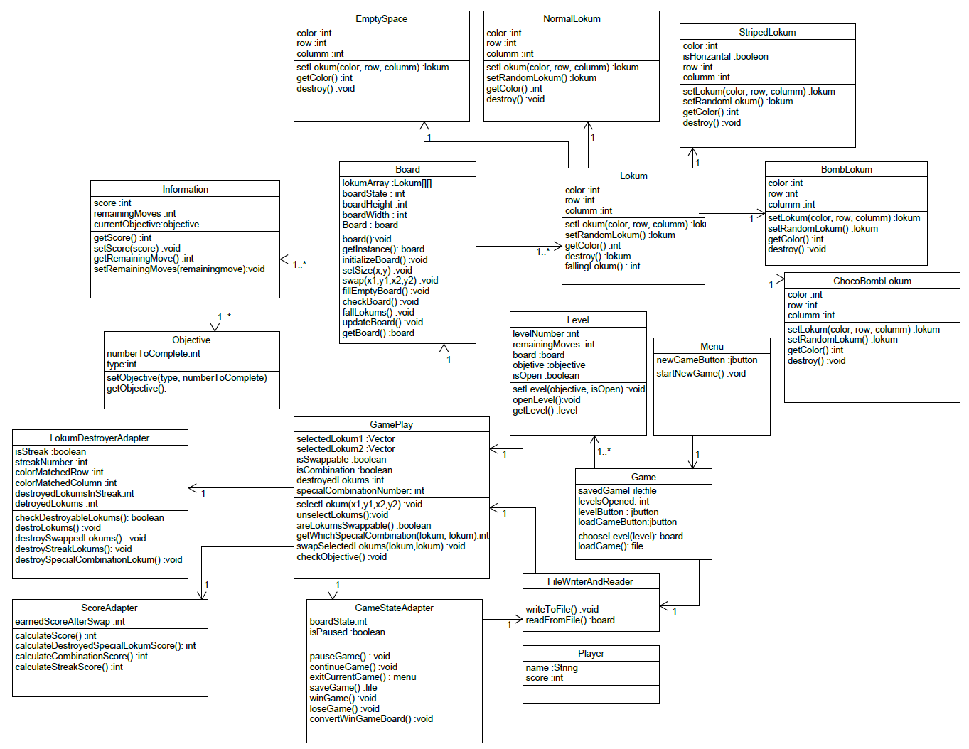

Figure 1: First Class Diagram

At the second step, we created a class diagram and enhanced the functionality and flexibility by adding adapters for all. Adapter side of class diagram is shown below.

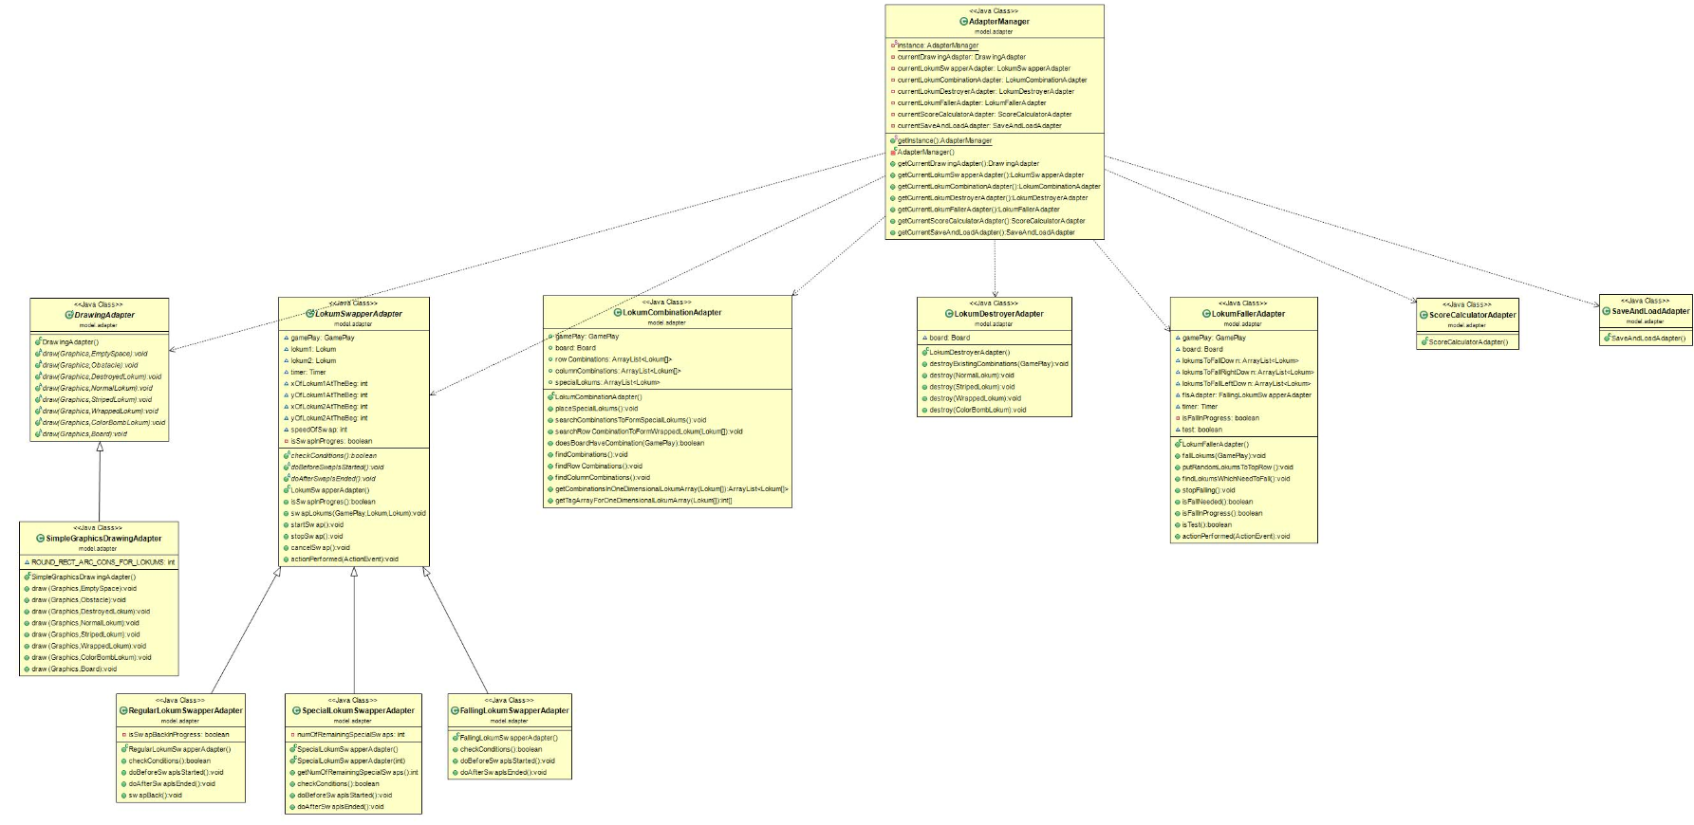

Figure 2: Adapter side of the Class Diagram

At this design, we have added adapters for each action to perform its specialty which is DrawingAdapter, LokumSwapperAdapter, LokumCombinationAdapter or LokumDestroyerAdapter, LokumFallerAdapter,ScoreCalculatorAdapter, SimpleGraphicsDrawingAdapter, RegularLokumSwapperAdapter, SpecialLokumSwapperAdapter and FallingLokumSwapperAdapter.

We have also improved user interface and made it more systematic as shown below picture.

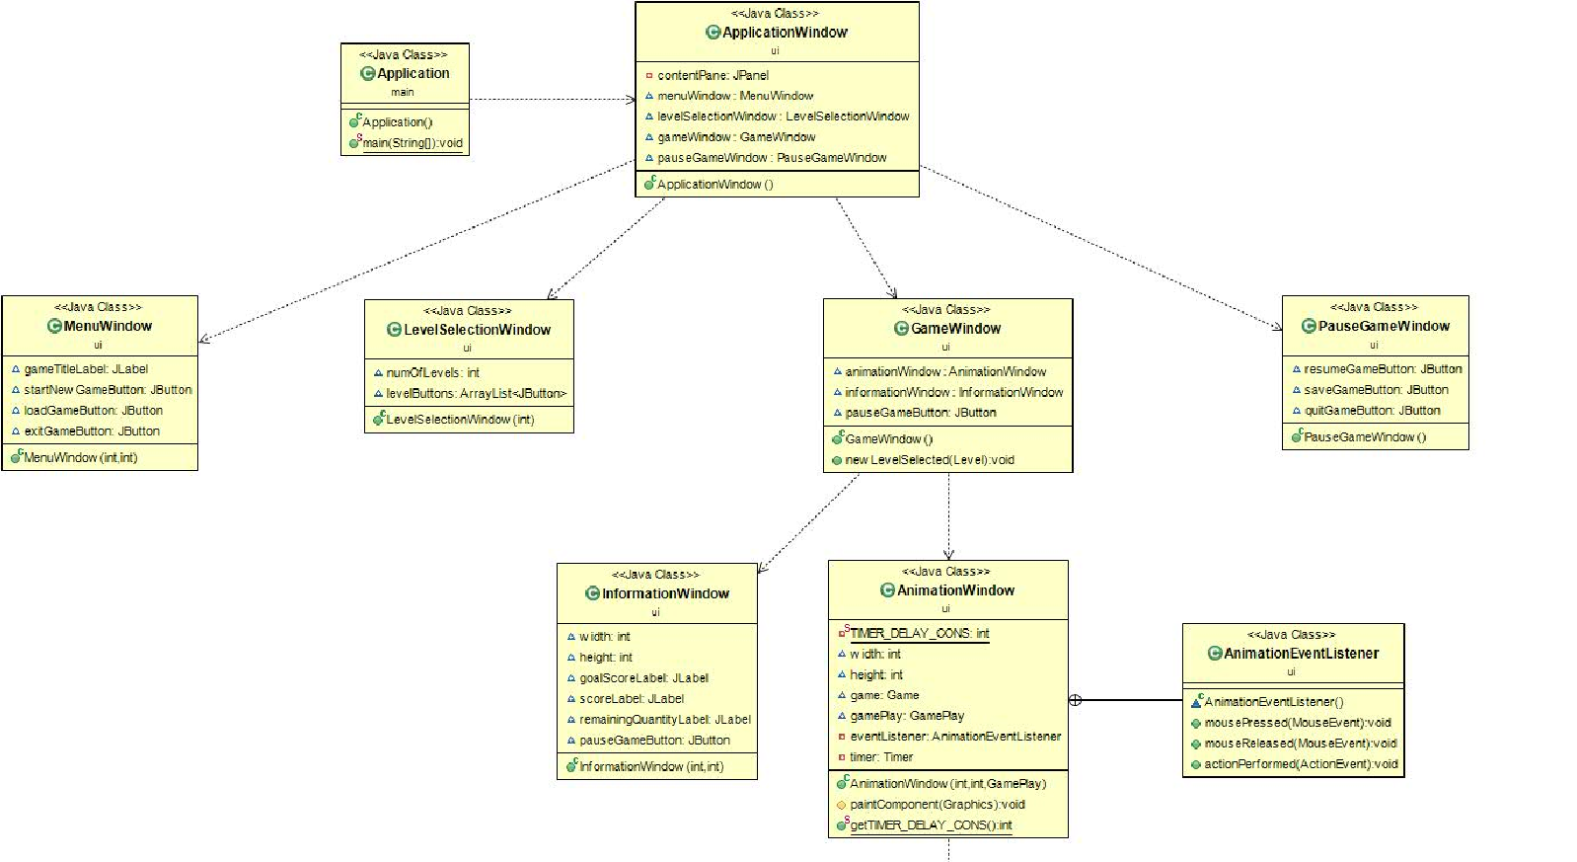

Figure 3: User interface of the Class Diagram

At the third and last process, with these adapters, we aimed to simplify design and provided to ease adding new extensions. In this way, we achieved our final class diagram which can be seen below.

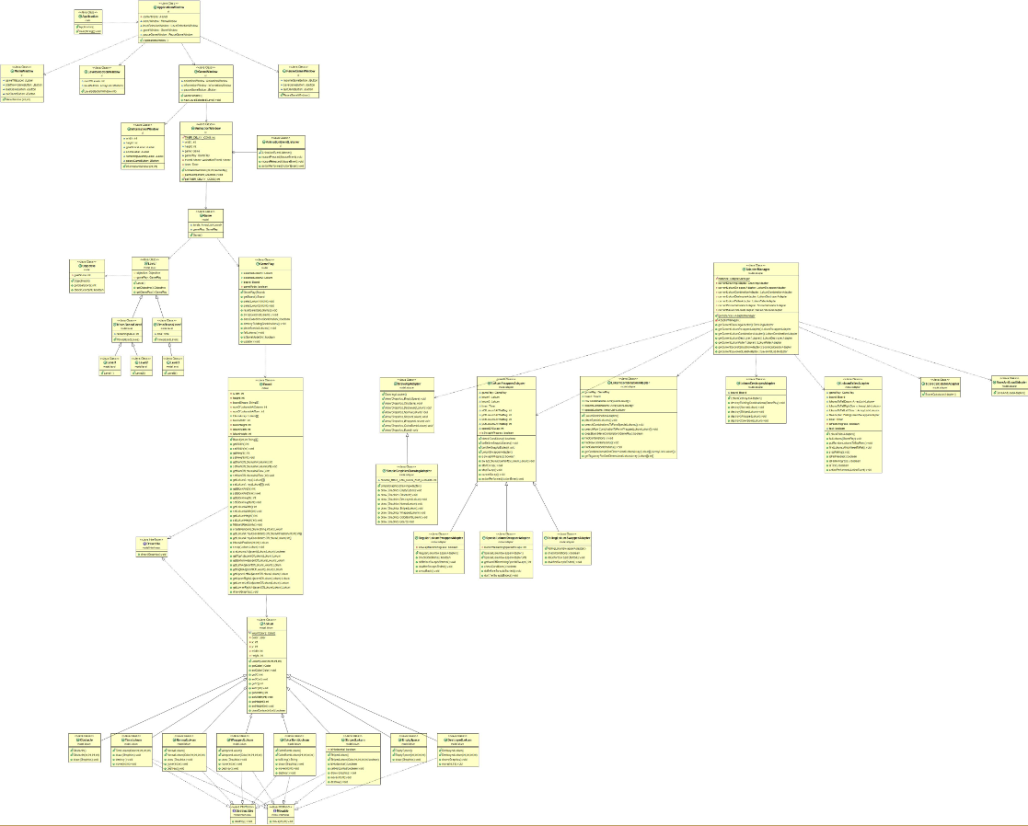

Figure 4: Our Final Class Diagram